PARADIGMA PEMBELAJARAN ERA DIGITAL DI SEKOLAH TINGGI AGAMA ISLAM BAHRIYATUL ULUM K.H. ZAINUL ARIFIN PANDAN

Ismail¹, Sugeng Sukoco², Herianto³, Mesiono⁴.
Universitas Islam Negeri Sumatera Utara, Program Doktor Manajemen Pendidikan Islam
Universitas Islam Negeri Sumatera Utara, Program Doktor Manajemen Pendidikan Islam
Universitas Islam Negeri Sumatera Utara, Program Doktor Manajemen Pendidikan Islam
Universitas Islam Negeri Sumatera Utara

*Korespodensi: ismail.ahmad0512@gmail.com , sugengsukoco0606@gmail.com , heribengk@gmail.com , mesiono@uinsu.ac.id

ABSTRACK
This study aims to explore the extent of the paradigm in learning adopted by the Bahriyatul Ulum K.H. Zainul Arifin Pandan Islamic College during the digital era as it is today. The descriptive method is a method used by researchers in analyzing data obtained through interviews, observations and documentation. The results of this study include: 1). Research-based learning by emphasizing lecturers and students so that in every learning they obtain research products / results as a form of contributing thoughts. 2). Multidirectional learning by making all media and other elements as learning resources. Lecturers are only as good as the corridors of lectures. 3). Monomedia learning becomes multimedia by utilizing aspects of learning as a means of supporting learning. 4). Group-based learning.

Keyword: Learning Paradigm, Digital Era.

ABSTRAK
Penelitian ini bertujuan untuk mengupas sejauh mana paradigma dalam pembelajaran yang dianut Sekolah Tinggi Agama Islam Bahriyatul Ulum K.H. Zainul Arifin Pandan pada masa era digital seperti saat ini. Metode kulitatif deskriptif menjadi cara yang digunakan peneliti dalam menganalisis data yang diperoleh melalui wawancara, observasi dan dokumentasi. Adapun hasil penelitian ini meliputi: 1). Pembelajaran berbasis riset dengan menekankan kepada para dosen dan mahasiswa agar dalam setiap pembelajaran memperoleh produk/hasil penelitian sebagai bentuk sumbangsih pemikiran. 2). Pembelajaran multiarah dengan menjadikan seluruh media dan unsur lain sebagai sumber belajar. Dosen hanya semabagi pengatur koridor jalannya perkuliahan. 3). Pembelajaran monomedia menjadi multimedia dengan memanfaatkan sebagala aspek pembelajaran sebagai sarana penunjang pembelajaran. 4). Pembelajaran berbassis kelompok.

Kata kunci: Paradigma Pembelajaran, Era Digital.

1. INTRODUCTION
The meaning of learning is the way that has been done by everyone since centuries ago. Basically the meaning of learning is not only limited to reading and memorizing but more than that. Austin et al., (2001:98) says that "Many classrooms today continue a transmission-based conception of learning as the passing on of information from the teacher to the student, with little interest in transforming it or using it for novel purposes". The fact is that currently a lot of learning is carried out in classrooms by only continuing the transmission-based learning concept. That is, learning is carried out only to convey information from the teacher to students and only a few efforts are made to use this information for new purposes (Maemunawati & Alif, 2020). This criticism emphasized that the learning carried out in educational efforts must be in accordance with the times. A lecturer cannot do one way of teaching that applies to all of his students with one-way lectures and expects students to understand the material and be able to do their own assignments. Rahadian, 2016) in his research explained that the implementation of education is aimed at helping humans make themselves what they are capable of, and an educator must be able to understand them in their actuality, possibilities and ideals and educators must know how to foster the changes desired by they.
Apart from that, the Indonesian education figure Ki Hajar Dewantara views education as an effort to advance the growth of character (inner strength, character), mind (intellect) and child's body (Djohar & Istiningsih, 2017). This meaning is in line with the goals of national education contained in Law number 20 of 2003, namely developing the potential of students to become human beings who believe in and fear God Almighty, have noble character, are healthy, knowledgeable, capable, creative, independent, and become democratic and responsible citizens (UUD No. 20, 2003).
Referring to Law no.12 article 4 of 2012 concerning higher education Kisworo, (2012) at least outlines three main objectives, namely:
- Develop capabilities and form dignified national character and civilization in the framework of educating the nation's life;
- Develop an innovative, responsive, creative, skilled, competitive and cooperative academic community through the implementation of the Tridharma; and
- Developing Science and Technology by paying attention to and applying Humanities values.
To carry out the three functions mentioned above, tertiary institutions must be able to organize learning that is very supportive of developing the potential of each student and effective teaching. In fact, in the challenges of globalization. The adaptability of tertiary institutions to the demands faced by students in improving their capabilities is a must.
Learning activities as an implementation of these goals must be able to create opportunities and opportunities for students to develop global competencies (Anggraeni et al., 2021). Where, the main elements of global competence include the habit of respecting, commitment to work together, and instilling a sense of responsibility (Octavia, 2019). The urgency of the quality of teaching and learning in higher education is very important to produce graduates who are able to adapt, be creative and think critically to build their future.
This context demands the restoration of education and learning in tertiary institutions according to the ideal vision and mission of building a religious nation. Universities carry out their functions and roles as a forum for student and community learning, centers for the development of science and technology, educational forums for future national leaders, centers for the study of virtues and moral strength to seek and find the truth, and centers for the development of national civilization The function and role of the tertiary institution can be realized if it is based on religious values ​​in the process of education and learning.character resilience religious for prospective national leaders.
However, the learning of Islamic religious education in tertiary institutions has stagnated progress for its alumni. The orientation and focus of teaching Islamic religious education is subject matter oriented, namely a learning process centered on imparting religious knowledge, in the sense of understanding and memorizing religious teachings in accordance with the established curriculum (Nata, 2012). The learning content of Islamic religious education is not yet productive and creative, so that Muslims are only able to express normative teachings that appear to have a gap with social reality. In connection with this discourse, (Halik, 2013) quotes Imre Lakatos' statement stating that "Why is there more discussion in the Islamic sciences that is directed at discussing 'hard core' (solid core teachings) which are defended with all their might and which cannot be falsified?" in the field, instead of having creative discussions on the domain of the 'protective belt' (safety belt of core teachings) which can actually be tested, strengthened, criticized, falsified, and possibly corrected.”
The learning paradigm is a correlation that is formed from several fields that are developed to understand history and social conditions so as to produce its own meaning. Many opinions have different opinions about this paradigm. The concept of paradigm was first introduced by Thomas Kuhn to see the development and revolution of the times (Mulawarman, 2010). Many educators still use the conventional paradigm, namely the teacher explains and the students listen. The impact is that students will find it easier to meet a saturation point in learning. Educators also don't give emotional touch to students, that's why they are never actively involved in learning. By using emotional memory, students will be more involved in their emotions to think critically about what they are learning at that time.
Many educators still use the conventional paradigm, namely the teacher explains and the students listen. The impact is that students will find it easier to meet a saturation point in learning. Educators also don't give emotional touch to students, that's why they are never actively involved in learning. By using emotional memory, students will be more involved in their emotions to think critically about what they are learning at that time.
As part of a review of previous research literature, the authors at least found several similar studies that discussed paradigms in learning in tertiary institutions. The first study was conducted by Rahadian, (2016) regarding shifts in the learning paradigm in tertiary institutions. In his research, he obtained results in the form of a change in the learning paradigm from a paradigm focused on teachers/lecturers to learning focused on students or students. In higher education, it is known as Student-Centered Learning as learning that focuses on students. The integration of educational institutions in producing quality learning carried out by lecturers and students is a complete form in this approach (Mesiono, 2022).
Furthermore, similar research reviewed from the MBKM curriculum conducted produced an idea in the form of a curriculum program aimed at encouraging students to be able to master various competencies and this program is expected so that students are able to improve graduate competencies both soft skills and hard skills to be ready with the needs of the times and prepare excellent, moral and ethical graduates.
Given the complexity of the problems in learning packaging, the learning paradigm is a part that must continue to be studied by experts and academics. In connection with the problems surrounding the learning paradigm in tertiary institutions, especially Islamic religious education, this mini-research aims to find out and examine how the learning perspective is used by Bahriyatul Ulum Islamic College KH Zainul Arifin Pandan in order to achieve educational goals.

2. TINJAUAN PUSTAKA
A paradigm is an approach of understanding something (Bagus, 2005: 779). According to Sjamsuar (2003, 28), a paradigm can be viewed of as the foundation for a school of thinking in science (the basic viewpoint). According to Muliartha (2010: 2), a paradigm is a way of thinking, examining, and comprehending a scientific subject and what to do. Definition In a nutshell, a paradigm is a way of thinking and seeing someone or something.
The shift in the educational paradigm continues dynamically following the changes in the global era and the era of autonomy that have developed from time to time. Along with that, the dynamics of development in the field of education continue to be pushed towards a more joyful and proud National Education constellation, not only for the educational community, but also for the nation and the State. Therefore, all development efforts in the field of education continue to be pursued in a dynamic, transparent, accountable and non-discriminatory manner so that through education generations are able to develop capabilities and shape national character, civilization and culture that are on par with other nations in the world.

3. RESEARCH METHODS
This research uses a qualitative approach (Qualitative research) which describes and analyzes phenomena, events, social activities, attitudes, beliefs, perceptions, thoughts of people as well as individuals and groups (Sugiyono, 2013). Furthermore, the data was collected by careful observation which included detailed contextual descriptions regarding the learning paradigm of Bahriyatul Ulum Islamic College KH Zainul Arifin Pandan
Research data were obtained through (1) interviews with university leaders, lecturers and students. (2) observation of ongoing activities and (3) documentation in the form of activity photos and collection of related documents (Rohman, 2021).

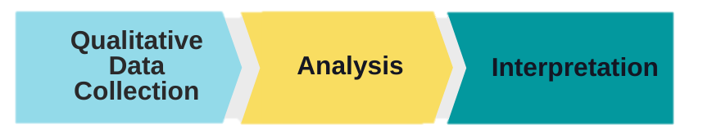

Gambar 1: Alur penelitian.

4. RESULTS AND DISCUSSION
4.1 Conventional learning paradigm towards digital learning
Learning and teaching are two concepts that cannot be separated from one another. Learning is the process of seeing, observing, and understanding something (Darman, 2020). Learning is not about memorizing and remembering, but learning is a process marked by changes in a person (Oktiani, 2017). Like learning, teaching is also a process. Teaching is the process of managing and organizing the environment around students so that it can grow and encourage students to carry out the learning process(Hidayat, 2012). he conventional learning paradigm which still considers the teacher as a learning center (teacher centered learning) or as the only source of learning should be changed because it is not in accordance with the principles of teaching and learning (learning) itself. Conventional learning is the teaching and learning process carried out in the old way, which still relies on lectures(Jayawardana, 2017).
In conventional learning, the teacher is the main resource, students participate in learning activities by listening to lectures and taking notes. Although conventional learning (lectures) is not always bad, it makes students more passive, so that it is less in line with the modern constructive learning paradigm. Paradigm is a way of looking at something. Meanwhile, according to Sjamsuar (2003, 28), paradigm can be synonymous as the basis of a scientific perspective or (basic point of view). Muliartha (2010: 2 efines a paradigm as a mindset, perspective on a scientific discipline and what must be questioned, studied, and understood. The definition of paradigm in brief is a person's mindset and perspective on something. It is time for teachers to change the paradigm from conventional/traditional learning to digital learning (e-learning) that utilizes computer and internet technology.
According Yazdi, (2012:14), the difference between traditional learning and e-learning is that in traditional learning the teacher is considered an all-knowing person and is tasked with imparting knowledge to students. Meanwhile, in e-learning, the main focus is students. The learning atmosphere of e-learning will make students more active in the learning process, because students can search for material with their own efforts and initiatives. E-learning is closely related to the use of computers/laptops/notebooks, the internet, and supporting electronic devices (Setyoningsih, 2015).
Teachers should be able to think openly (open minded) on today's technological developments, bearing in mind that most students are internet users and various kinds of technological applications, especially computers and smartphones. According to data from the Ministry of Communication and Informatics here were 82 million internet users in Indonesia until 2014. Indonesia is ranked 8th as internet users in the world. 80 percent of these internet users are teenagers aged 15-19 years (Kemkominfo, 2014: 1).

4.1.1 The learning paradigm of the Bahriyatul Ulum Islamic High School K.H. Zainul Arifin
The occurrence of a shift in the learning paradigm is one of them caused by the demands of learning supported by science and technology. through increasing science and technology, it is hoped that students will be able to increase their learning efforts and increase their knowledge and skills. Referring to the meaning of the paradigm itself, a learning should have a point of view that is used in determining the direction of the goal to make it easier to obtain the expected results. Likewise the learning concept in the Bahriyatul Ulum Islamic High School KH Zainul Arifin Pandan. The learning paradigm makes learning and teaching activities come alive. Based on the author's observations, at least the learning paradigm as a point of view that arises due to a shift in the learning paradigm in general, there are five things that are part of the learning paradigm at Bahriyatul Ulum Islamic College KH Zainul Arifin Pandan. These five things can be described as follows:

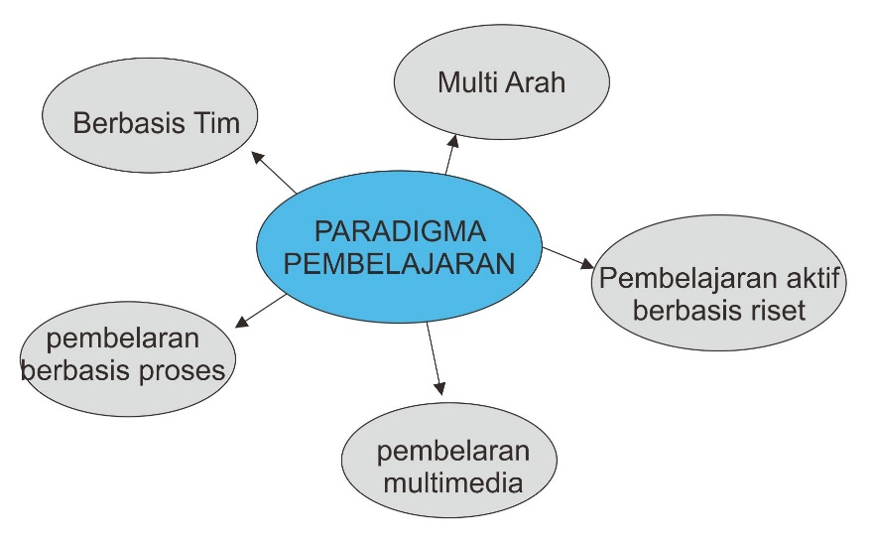
.
Gambar 2: learning paradigm
- Multi-Way Learning

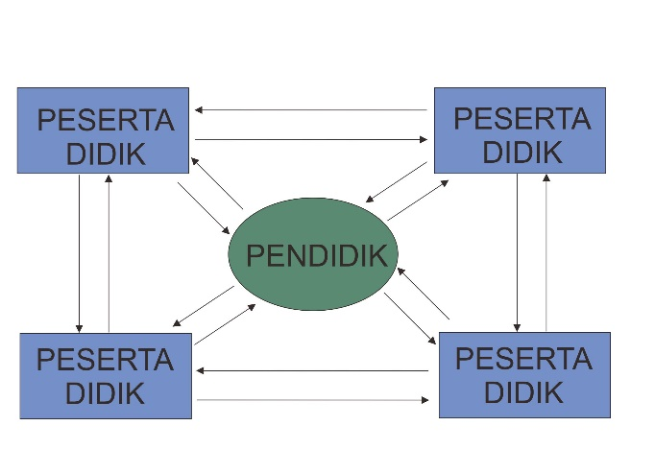

Gambar 3: multi-directional learning scheme

The occurrence of a shift in the learning paradigm is one of them caused by the demands of learning supported by science and technology. through increasing science and technology, it is hoped that students will be able to increase their learning efforts and increase their knowledge and skills. Referring to the meaning of the paradigm itself, a learning should have a point of view that is used in determining the direction of the goal to make it easier to obtain the expected results. Likewise the learning concept in the Bahriyatul Ulum Islamic High School KH Zainul Arifin Pandan. The learning paradigm makes learning and teaching activities come alive. Based on the author's observations, at least the learning paradigm as a point of view that arises due to a shift in the learning paradigm in general, there are five things that are part of the learning paradigm at Bahriyatul Ulum Islamic College KH Zainul Arifin Pandan. These five things can be described as follows:

“"everyone knows, learning activities both in class and outside the classroom are the main and main steps in achieving the desired competency goals”. Therefore it can also be understood that learning activities are the spearhead of education itself. Therefore, learning activities must also be packaged in such a way as to facilitate the achievement of the desired competencies. Apart from that, referring to the ongoing development of the times, learning activities must also be in line. For example, multi-directional learning that has been delivered before. This multi-directional learning is important to carry out so that an even distribution of competency achievement appears. All students can play an active role in contributing ideas. Even if it's right or wrong. And this multi-way learning is part of what the Bahriyatul Ulum Islamic High School KH Zainul Arifin Pandan runs.".”

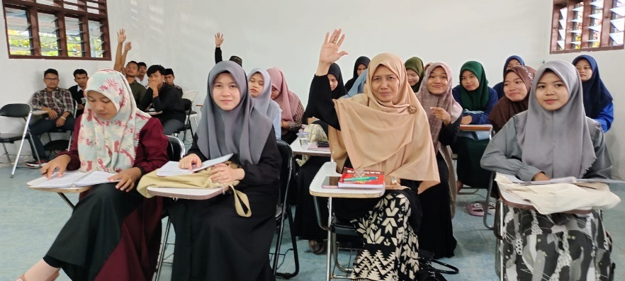

Gambar 4: aktivitas pembelajaran

- Research-based active learning
The occurrence of a shift in the learning paradigm is one of them caused by the demands of learning supported by science and technology. through increasing science and technology, it is hoped that students will be able to increase their learning efforts and increase their knowledge and skills. Referring to the meaning of the paradigm itself, a learning should have a point of view that is used in determining the direction of the goal to make it easier to obtain the expected results. Likewise the learning concept in the Bahriyatul Ulum Islamic High School KH Zainul Arifin Pandan. The learning paradigm makes learning and teaching activities come alive. Based on the author's observations, at least the learning paradigm as a point of view that arises due to a shift in the learning paradigm in general, there are five things that are part of the learning paradigm at Bahriyatul Ulum Islamic College KH Zainul Arifin Pandan. These five things can be described as follows
"everyone knows, learning activities both in class and outside the classroom are the main and main steps in achieving the desired competency goals. Therefore it can also be understood that learning activities are the spearhead of education itself. Therefore, learning activities must also be packaged in such a way as to facilitate the achievement of the desired competencies.
Apart from that, referring to the ongoing development of the times, learning activities must also be in line. For example, multi-directional learning that has been delivered before. This multi-directional learning is important to carry out so that an even distribution of competency achievement appears. All students can play an active role in contributing ideas. Even if it's right or wrong. And this multi-way learning is part of what the Bahriyatul Ulum Islamic High School KH Zainul Arifin Pandan runs."
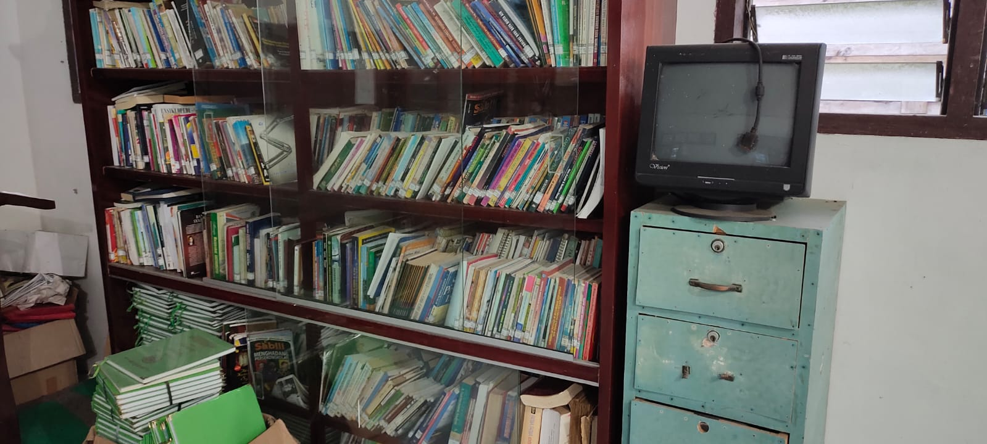

Gambar 5: supporting documents for research-based learning (literature study)

- Monomedia-multimedia
As previously mentioned, changes in civilization have an impact on changes in the learning paradigm in all areas, from elementary education to tertiary institutions. Conventional learning models that only make educators the main source of teaching materials are starting to become irrelevant to factual conditions. This fact is also part of what is felt by the Bahriyatul Ulum Islamic High School KH Zainul Arifin Pandan. The learning process began to shift towards modernity by utilizing everything as a medium for conveying messages. Digital-based learning media is a mandatory facility that needs to be prepared in lectures. Even though the fulfillment of all digital facilities has not been fully fulfilled, at least the campus has tried to balance the changes in civilization that have occurred.
An interview with one of the Bahriyatul Ulum Islamic College students KH Zainul Arifin Pandan stated that:
"the teaching and learning process carried out by the lecturer varies. The variation is most visible in the use of learning media. Lecturers do not only use projector media in conveying lecture material but often also combine it with other media such as WhatsApp, Google Meet, Zoom, YouTube and others. We think that the variety of media used adds to our knowledge. Yes, even though the many uses of media are used to increase our knowledge, but at least we know that learning does not only have to come from lecturers or teachers at schools or campuses”.

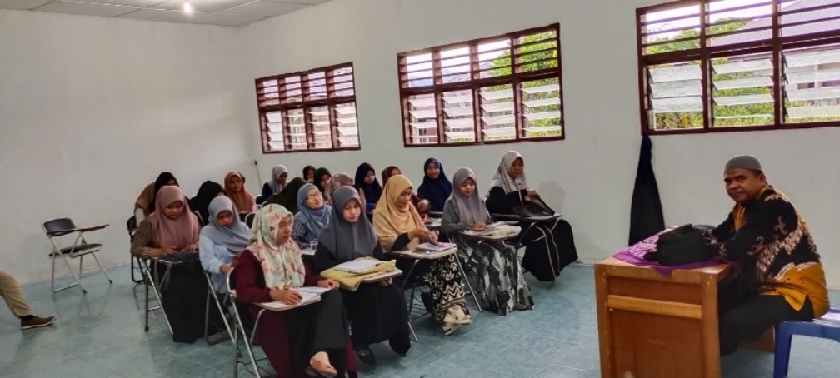

Gambar 6: interviews with students of the Bahriyatul Ulum Islamic High School K.H. Zainul Arifin Pandan

If we look at Multimedia according to its language origin, it comes from the word "multus" which means many or more than one. And the media comes from the Latin word medius which is the plural form of the word "medium", which means intermediary or introduction. In this sense, teachers, books, and the school environment are media. Media is everything that is used as a message distributor and sends messages, so that it can stimulate thoughts, concerns, feelings and also the interests and attention of students in such a way that the teaching process can take place effectively and efficiently as expected. based on research data, the use of learning multimedia has a significant influence on achieving student.

- Team-based learningm
In the context of implementing team-based learning, basically it can go hand in hand with research-based learning. Team-based learning can be taken in another sense as team-based learning, which means innovative teaching and learning methods by studying in small groups in large classes. This method depends on the process of assigning members to groups of five to seven people per group who will function as a team. Team Base learning (TBL) is an innovative educational strategy that relies on student-centered and structured teaching and learning activities to enhance the learning process.
Based on the author's observations, learning activities at the Bahriyatul Ulum Islamic High School KH Zainul Arifin Pandan show that team-based learning is the learning paradigm used in learning activities. Each student lecture meeting is burdened with material that must be completed in groups. The application of group learning is not only in research-based courses but in almost all courses.
The writer's findings are supported by the results of an interview with one of the teaching lecturers at the Bahriyatul Ulum Islamic High School KH Zainul Arifin Pandan. In his interview he explained that:
“"group division is an integral part of lecture activities on our campus. Even so, not all learning can be applied to group learning. This is all adjusted to the context of the lecture material being undertaken. The basis for group-based learning is part of the paradigm on our campus, with student groups being more proactive in conveying ideas and opinions. This is based on his confidence alog with his friends. When compared with ordinary conventional learning, of course there are differences, sir.”

5. KESIMPULAN
A higher education institution is required to carry out community service, research, and education. Higher education should therefore prepare all elements required to fulfill educational objectives. One of the many factors that determine the path of reaching educational objectives is paradigm or point of view. Educational institutions become more vibrant and have traits that reflect their personality thanks to paradigm. The institution's internal and external elements drive these features. Globalization is one of the key elements in the paradigm shift in education. In particular, his teaching paradigm at the Bahriyatul Ulum Islamic High School, K.H. Zainul Arifin Pandan, was affected by this.

DAFTAR PUSTAKA
Anggraeni, C., Elan, E., & Mulyadi, S. (2021). Metode Pembiasaan Untuk Menanamkan Karakter Disiplin Dan Tanggungjawab Di Ra Daarul Falaah Tasikmalaya. Jurnal Paud Agapedia, 5(1), 100–109.
Austin, K., Orcutt, S., & Rosso, J. (2001). How People Learn: Introduction To Learning Theories. The Learning Classroom: Theory Into Practice–A Telecourse For Teacher Education And Professional Development.
Bagus, Lorens. 2005. Using Google Hangout in Education
Barus, N. B. (2021). Hubungan Variasi Mengajar Dengan Motivasibelajar Siswa Kelas Iv Sd Negeri 040530 Bunuraya Tahun Pelajaran 2020/2021 [Phd Thesis]. Universitas Quality Berastagi.
Darman, R. A. (2020). Belajar Dan Pembelajaran. Guepedia.
Djohar & Istiningsih. (2017). Filsafat Pendidikan Ki Hadjar Dewantara Dalam Kehidupan Nyata. Suluh Media.
Halik, A. (2013). Paradigma Pembelajaran Pendidikan Agama Islam Di Perguruan Tinggi. Jurnal Al-‘Ibrah, 2(1), 11–22.
Hidayat, N. S. (2012). Problematika Pembelajaran Bahasa Arab. Jurnal Pemikiran Islam, 37(1).
Indonesia, P. R. (2003). Undang-Undang Republik Indonesia Nomor 17 Tahun 2003 Tentang Keuangan Negara.
Jayawardana, H. B. A. (2017). Paradigma Pembelajaran Biologi Di Era Digital. Jurnal Bioedukatika, 5(1), 12–17.
Kisworo, M. (2012). Undang-Undang No. 12 Tahun 2012 Tentang Pendidikan Tinggi.
Mesiono. (2022). MODEL OF EDUCATION MANAGEMENT USING QUALITATIVE RESEARCH. 28(2), 88–93
Maemunawati, S., & Alif, M. (2020). Peran Guru, Orang Tua, Metode Dan Media Pembelajaran: Strategi Kbm Di Masa Pandemi Covid-19. 3m Media Karya.
Mulawarman, A. D. (2010). Integrasi Paradigma Akuntansi: Refleksi Atas Pendekatan Sosiologi Dalam Ilmu Akuntansi. Jurnal Akuntansi Multiparadigma, 1(1), 155–171.
Muliartha, I Wayan. 2010. Ekplorasi Pemikiran Tentang Paradigma, konsep, Dalil, dan Teori. Buleleng: Undiksha
Nata, H. A. (2012). Manajemen Pendidikan: Mengatasi Kelemahan Pendidikan Islam Di Indonesia. Kencana.
Octavia, S. A. (2019). Sikap Dan Kinerja Guru Profesional. Deepublish.
Oktiani, I. (2017). Kreativitas Guru Dalam Meningkatkan Motivasi Belajar Peserta Didik. Jurnal Kependidikan, 5(2), 216–232.
Rahadian, D. (2016). Pergeseran Paradigma Pembelajaran Pada Pendidikan Tinggi. Jurnal Petik, 2(1), 1–7.
Rohman, N. (2021). Analisis Teori Behaviorisme (Thorndike) Pada Pelajaran Matematika Dan Bahasa Indonesia Sdn Upt Xvii Mukti Jaya Aceh Singkil. Abdau: Jurnal Pendidikan Madrasah Ibtidaiyah, 4(2), Article 2. Https://Doi.Org/10.36768/Abdau.V4i2.210
Sardiman, A. M. (2011). Interaksi Dan Motivasi Belajar Mengajar/Sardiman Am.
Setyoningsih, S. (2015). E Learning: Pembelajaran Interaktif Berbasis Teknologi Informasi. Elementary: Islamic Teacher Journal, 3(1).
Simatupang, E., & Yuhertiana, I. (2021). Merdeka Belajar Kampus Merdeka Terhadap Perubahan Paradigma Pembelajaran Pada Pendidikan Tinggi: Sebuah Tinjauan Literatur. Jurnal Bisnis, Manajemen, Dan Ekonomi, 2(2), Article 2. Https://Doi.Org/10.47747/Jbme.V2i2.230
Sjamsuar, Zumri Bestado, 2003. Paradigma Manusia Surya: Membongkar Mitos Parokhialitas Sumber Daya Manusia, Pontianak: Yayasan Insan Cita
Sugiyono, D. (2013). Metode Penelitian Pendidikan Pendekatan Kuantitatif, Kualitatif Dan R&D.
Sulaiman, A., & Wibowo, U. B. (2016). Implementasi Sistem Penjaminan Mutu Internal Sebagai Upaya Meningkatkan Mutu Pendidikan Di Universitas Gadjah Mada. Jurnal Akuntabilitas Manajemen Pendidikan, 4(1), 17–32.
Usman, M. U. (2001). Menjadi Guru Profesional Cet. Xiii. Bandung: Remaja Rosdakarya.
Yazdi, M. (2012). E-Learning Sebagai Media Pembelajaran Interaktif Berbasis Teknologi Informasi. Foristek, 2(1).

